SUMMER
SCHOOL
July 30 - August 8, 2017
Graduate School of Advanced
Science and Technology,
Tokushima University,
Japan
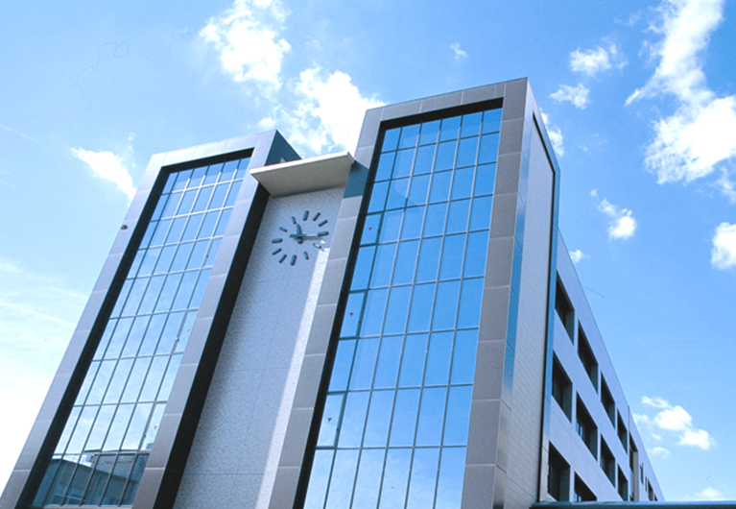

Sponsors:
- Center for International Cooperation in Engineering Education (CICEE)
- The International Center
- Tokushima University

tion
Introduction

Tokushima University is pleased to invite you to participate in the International Summer School which runs from July 30 to August 8, 2017. The Summer School Program was initiated by Center for International Cooperation in Engineering Education (CICEE) to build the understanding and awareness of course subject as well as to increase the knowledge and practical skills.
The prime aim is to provide the platform to young scientists involved in interdisciplinary research and to develop collaborative partnerships on different areas.
Location

Tokushima city is located in the eastern part of Shikoku island. The population of Tokushima is about 500,000. The Kansai International Airport is located 180 km away from Tokushima. The Tokushima city has connected by bus with the Kansai International Airport (165 min).
Who can apply?

The Summer School is open to the Doctoral students and Master students who are working on Nanotechnology, Materials Science; Electrical Engineering; Information Science and related topics. Researchers must be affiliated to a university and have a good knowledge of English.
How to apply

Applicants should submit:
- A completed Registration form
- Scanned file of passport (face page)
- Letter of Motivation includes few lines about your research topic and the progress your have made in your research (300 words).
Completed application form should be send by an email to
ss.cicee@ml.tokushima-u.ac.jp

Deadline for application

The call for applications closes on June 10, 2017. You will be notified by email around June 20 about your acceptance.
Certificate

All participants registered for Summer School, they will receive an official certificate from Tokushima University. The course leads to 2 credits. However, these credits points are recognized depends on each participant’s university and Master/PhD program.
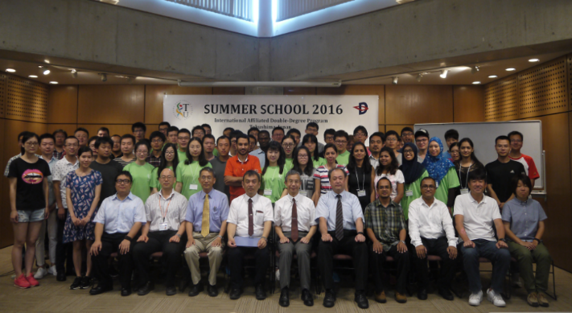

Internship

All participants are encouraged to join the One-Day-Internship, You
can choose the lab, which you are interested in, to experience the daily
research with the local students.
Contact

Center for International Cooperation in Engineering Education (CICEE),
Tokushima University 2-1 Minamijosanjima Cho,
Tokushima- 770-8506,
Japan
Phone. and Fax : +81-88-656-7643
Email: ss.cicee@tokushima-u.ac.jp

Program

The Summer School runs for two weeks. The Summer School is suitable for Master and PhD students who have decided on a research topic and have already started some research activities. It offers a series of courses taught in English as follows:
- Nanotechnology and Materials Science

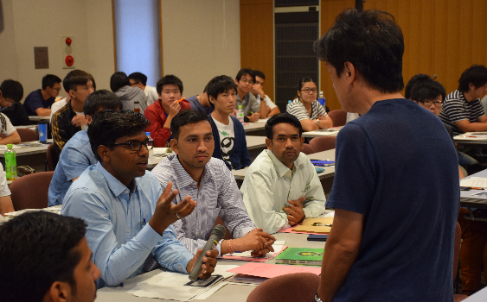
This course will focus on recent developments in advanced materials and nanotechnology. The basic purpose is to promote and enhance the intensive theoretical and experimental approach to study of various advanced materials and their properties. This course will bring together researchers in the field of Physics, Chemistry, Nanotechnology, Advanced materials, Characterization technique, and Synthesis methods. Thus, this course is planned to help participants who are involved in the fundamentals and application of Materials Science and Nanotechnology. In addition, participant will have an opportunity to meet the experts and visit the laboratories.
2. Electrical Engineering and Information
Science

This course will focus on recent works in electrical and electronic engineering. The topics of this course will be designed as follows: Semiconductor device and its application, Challenges in Electrical power，Discharge plasma, ,Introduction of Biometrics, image features and extraction methods, Machine Learning Systems, Human behavior analysis.
3. Civil and Environmental Engineering

This course will focus on recent advances in civil and environmental
engineering. The topics of the course will cover as follows: Durability
evaluation and rehabilitation techniques of infrastructures, Earthquakes
and Tsunami predictions and their countermeasures, Regional ecosystem
conservation and disaster mitigation utilizing Green Infrastructures,
Regional planning and land utilization guide under depopulation and
aging society.
Social Events and Summer School fees

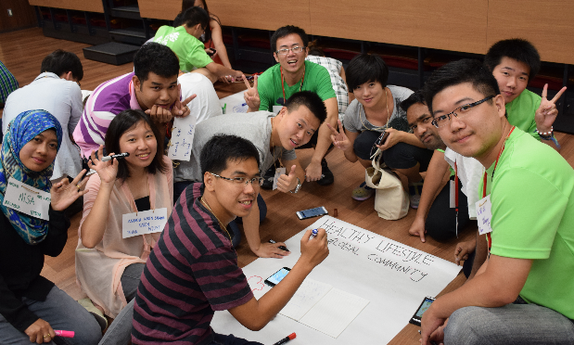
Summer School students will join social events and Japanese culture experience. Social events include day visit to traditional Japanese village,

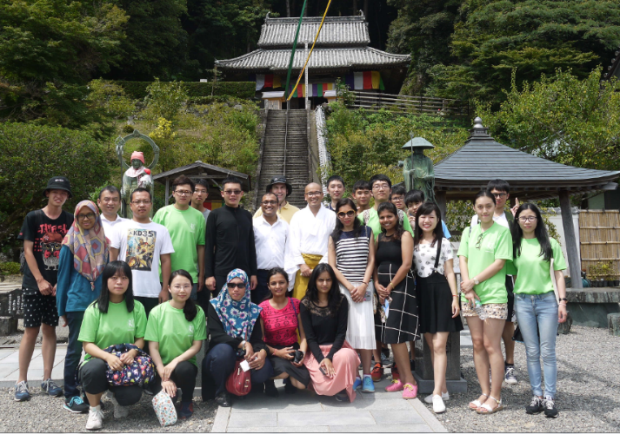

Intercultural party, and field trip. Summer School fees amounts to 3000 Yen. The Summer School fee includes the social events. The Summer School fees will be collected at the registration on July 30, 2017.

Registration form
- Family Name : ………..……..................………....................…………
Given Name : .................................... .....................................
- Gender: Male Female
- Telephone/Cellphone : ....................................................................
- E-mail : ……………………………………………………………….
- Postal Address for Correspondence :
...................................................................................................................................
.....................................................................................................................................
- Nationality : .........………………………………………………..
- Passport Number : ………………………………………………
- Date and Place of Birth : ……...................................................................
- Name of Home University and Department: .........................
........................................................................................ ............. ........................ .....................
Date of Enrollment (Year/Month): ………………… / …………
Date of Expected Graduation(Year/Month): ………………… / …………
Major (Name of Degree) :
Current School Year:
Current School Grade (GAP/Average Grade):
- Which course you want to apply for
Nanotechnology and Materials Science
Electrical Engineering and Information Science
Civil and Environmental Engineering

I declare that the information reported on this form is true and complete.

Signature : ...........................……………………
Date : ...........................……………………

